17th North-America Europe Data Exchange Group
EUMETSAT Status Report

1. The status of the 1st Generation Satellites

Three satellites of the Meteosat First Generation (MFG) satellites are currently operational. Parallel operations to the Meteosat-Second Generation-1 (MSG-1) satellite is provided by Meteosat-7 located at 0º, the Indian ocean Data Coverage (IODC) by Meteosat-5 at 63 º E and the Rapid Scan Service by Meteosat-6 10º E. This three satellites provide the full set of services including Image acquisition, rectification and dissemination, Meteorological Data Distribution and Meteorological Product Extraction and Dissemination. All products are derived and disseminated in real time from every acquired image, i.e. every half an hour for Meteosat-5 and –7 and every 10 min for Meteosat-6. The Meteosat-6 Meteorological Product suite is a subset of the full suite provided by the other satellites and the real time dissemination is composed of Atmospheric Motion vectors and Clear Sky Radiances only. Additionally to the real/near-real time activities the MFG Ground Segment has a full reprocessing capacity enabling the extraction of historical image data and the provision of meteorological products with the state of the art product generation algorithms. The reprocessed data has amongst other applications, been used successfully by ECMWF for their reprocessing activities.

Though all spacecrafts are performing well, there is currently not enough fuel left for inclination manoeuvres. Therefore the inclination is currently increasing and has reached for Meteosat-7, Meteosat-5 and Meteosat-6 0.7, 3.9 and 6.7 degrees respectively. It is currently foreseen to continue the operation of the first generation satellites until the end of 2008, guaranteeing the IODC coverage.

2. Meteosat-8 (Meteosat Second Generation-1)

The commissioning of MSG-1 was completed in December 2003 and the satellite entered full operations as Meteosat-8 in January 2004. In February some further Image and Product Validation activities took place and the IPVR (Image and Product Validation review) close-out was held successfully in March 2004. The main outcomes of the IPVR were that the quality of the image data is within the specifications and that the product quality is similar or better to that of the Meteosat-7. It is however expected that further improvements will take place during the operations phase. Table 1 presents the status of the meteorological products derived centrally at EUMETSAT. Some sample products are presented in Figures 1 and 2.

It should also be noted that preparations for the launch of MSG-2 are well under way. The currently planned launch date is mid-2005 and it is expected that the commissioning will end during the 3rd quarter of 2005.

Table 1. The status of the meteorological products extracted centrally with Meteosat-8. 1) Partial Seasonal Validation, 2) Internal Products Only.
Products | Acronym | UMARF Archive | GTS | EUMETCast | Validated at IPVR close-out
Atmospheric Motion Vectors | AMV | Yes | Yes | Yes | Partial (1)
Cloud Analysis | CLA | Yes | Yes | Yes | Yes
Cloud Analysis Image | CLAI | Yes | No | Yes | Yes
Cloud Mask | CLM | Yes | No | Yes | Yes
Cloud Top Height | CTH | Yes | No | Yes | Yes
Clear Sky Radiance | CSR | Yes | Yes | No | Yes
Climate Data Set | CDS | Yes | No | No | Yes
High Resolution Precipitation Index | HPI | Yes | No | No | Yes
ISCCP Data Set AC, B1 & B2 | IDS | Yes | No | No | Yes
Tropospheric Humidity | TH | Yes | Yes | Yes | Partial (1)
Total Ozone | TOZ | Yes | Yes | Yes | Yes
Sea Surface Temperature (2) | SST | No | No | No | Yes
Scenes Analysis (2) | SCE | No | No | No | Yes
Radiative Transfer Model (2) | RTM | No | No | No | Yes
Calibration Support | CAL | Yes | No | No | Yes
Global Instability | GII | Yes (4) | No | Yes | Yes

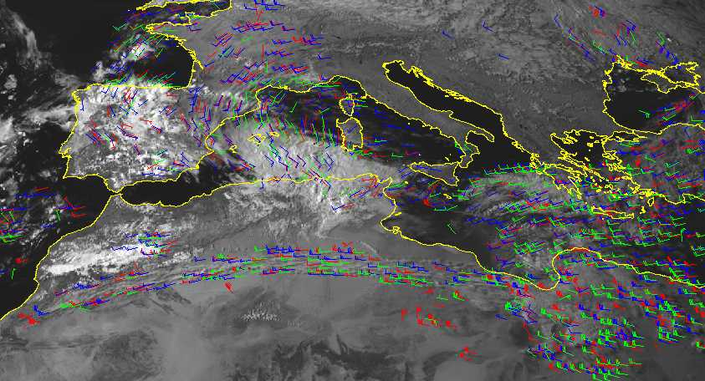
Figure 1. Atmospheric Motion Vectors derived with Meteosat-8 data. Please note the well-depicted high level jet over Northern Africa derived from very thin cirrus.
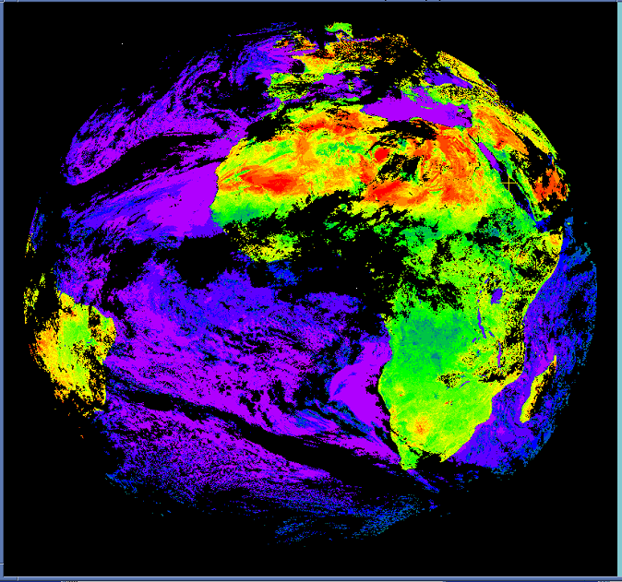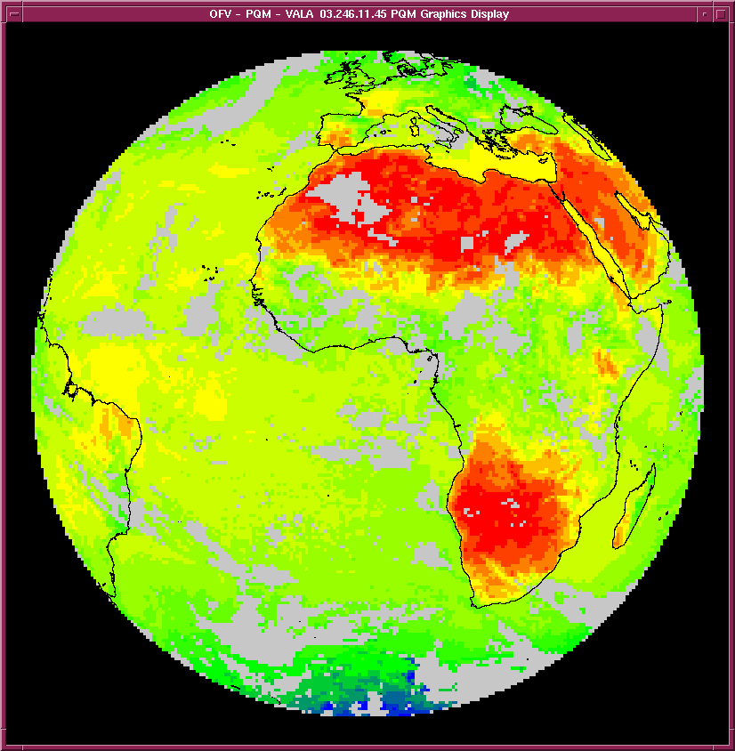

Figure 2. Clear-sky reflectance Map derived with accumulated data from a visible channel and a Clear Sky Radiance product for the IR window channel derived with Meteosat-8.

3. Meteosat-8 dissemination

Due to a failed Solid State Power Amplifier (SSPA) the Meteosat-8 onboard dissemination capability cannot be used. Therefore an alternative dissemination method EUMETCast has been put in place. The EUMETCast system relies on commercial telecommunications satellites and disseminates all image data and products over the European region in Ku-band. The system is currently used for data from the first and second generation Meteosat satellites and the EUMETSAT ATOVS Retransmission System. (Figure 3.) Additionally data from some European meteorological Services are included. For the African region a turn-around system is used to further disseminate the data in C-Band, where a Ku-band reception station in Italy is re-transmitting the data via C-band. The current bandwidths of the Ku and C-band are 2.5 and 2.7 Mbps respectively. Additionally, the Meteosat-8 data is provided to US (Wallops) via a dedicated landline.

Figure 3. The EUMETCast data distribution system.

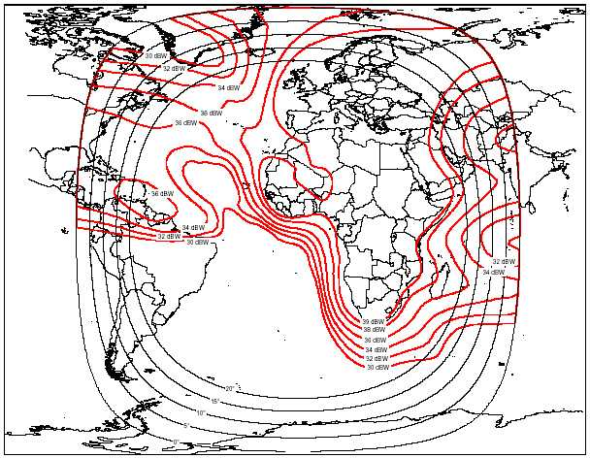

Figure 4. The C-band coverage of EUMETCast.
Currently, the main shortcoming of the alternative dissemination is limited coverage in South-America as shown in Figure 4. Various solutions for the South-American coverage are currently explored.

4. The EUMETSAT ATOVS Retransmission System

The EUMETSAT ATOVS Retransmission System (EARS) is currently covering roughly 2/3 of the Northern Hemisphere ensuring a data timeliness of 30 min within observation for the ATOVS level 1c data. The current data coverage, with coverage frequency indicated, is given in Figure 5. EUMETSAT is currently looking for an extension of the EARS service that would further improve the coverage, include limited retransmission of AVHRR data (over Europe), include ASCAT data after the launch of METOP-1 and to continue the service until the end of 2008.
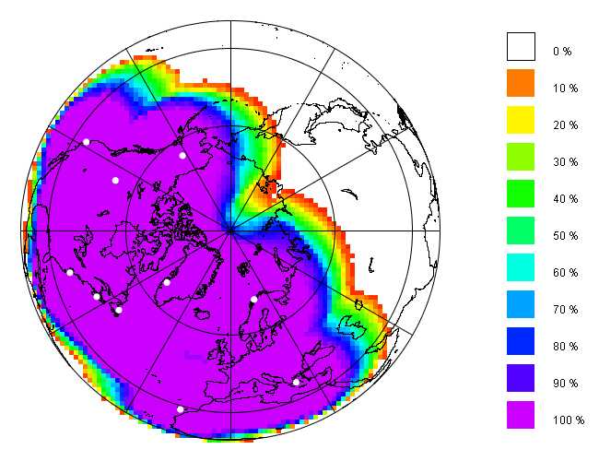
Figure 5. The current EARS data coverage.

5. The EUMETSAT Polar System

The first EUMETSA Polar System Satellite, METOP-1 is planned for launch in the 4th quarter of 2005. One important current activity is the provision of updated information, test data, formats and tools to the users. The information is provided sequentially and the first sets are already available on the EUMETSAT WEB site at:
http://www.eumetsat.de/en/area4/eps/user_information.html

6. JASON-2

The Jason-2 optional programme was started in June 2003 when 13 EUMETSAT Member States confirmed their subscription to the project, covering 90 percent of the 30 million euros needed for the programme. Jason-2 follows the Jason-1 and TOPEX/Poseidon missions begun in December 2001 and in 1992 respectively. Jason-2 is intended to overlap with Jason-1 to allow more precise cross-calibration between the two systems within a few tens of millimetres. EUMETSAT will host the European Earth terminal to retrieve data and to process and distribute Near Real Time products to users. The involvement of EUMETSAT and NOAA – two operational agencies - marks the programme’s transition to operational oceanography. When real time support becomes available, the programme will assist offshore operations and ship routing services, among others. JASON-2 is currently foreseen to be launched in 2008.

